Homework: Graph Algorithms
This document defines the homework assignments for the "Algortihms" course @ Software University. Please submit a single zip / rar / 7z archive holding the solutions (source code) of all below described problems.

Distance between Vertices
We are given a directed graph consisting of N vertices and M edges. We are given also a set of pairs of vertices. Find the shortest distance between each pair of vertices or -1 if there is no path connecting them. There are no specified requirements for the input and output, so you may hardcode the input and output values.
Examples:
Input | Picture | Output
Graph:  1 -> 2  2 ->  Distances to find:  1-2  2-1 | 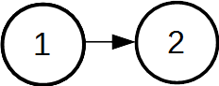 | {1, 2} -> 1  {2, 1} -> -1
Graph:  1 -> 4  2 -> 4  3 -> 4, 5  4 -> 6  5 -> 3, 7, 8  6 ->  7 -> 8  8 ->  Distances to find:  1-6  1-5  5-6  5-8 | 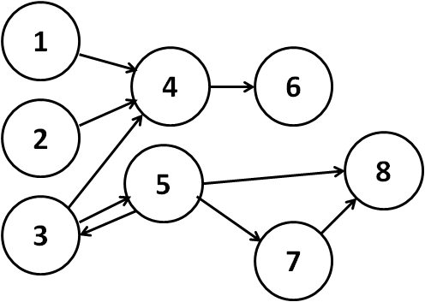 | {1, 6} -> 2  {1, 5} -> -1  {5, 6} -> 3  {5, 8} -> 1
Graph:  11 -> 4  4 -> 12, 1  1 -> 12, 21, 7  7 -> 21  12 -> 4, 19  19 -> 1, 21  21 -> 14, 31  14 -> 14  31 ->  Distances to find:  11-7  11-21  21-4  19-14  1-4  1-11  31-21  11-14 | 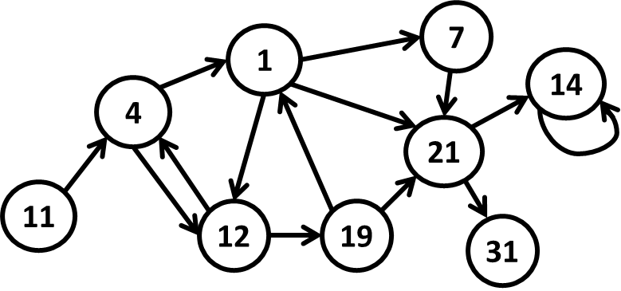 | {11, 7} -> 3  {11, 21} -> 3  {21, 4} -> -1  {19, 14} -> 2  {1, 4} -> 2  {1, 11} -> -1  {31, 21} -> -1  {11, 14} -> 4
Hint: for each pair use BFS to find all paths from the source to the destination vertex.

Areas in Matrix
We are given a matrix of letters of size N * M. Two cells are neighbor if they share a common wall. Write a program to find the connected areas of neighbor cells holding the same letter. Display the total number of areas and the number of areas for each alphabetical letter.
Examples:
Input | Picture | Output
Number of rows: 6  aacccaac  baaaaccc  baabaccc  bbdaaccc  ccdccccc  ccdccccc | 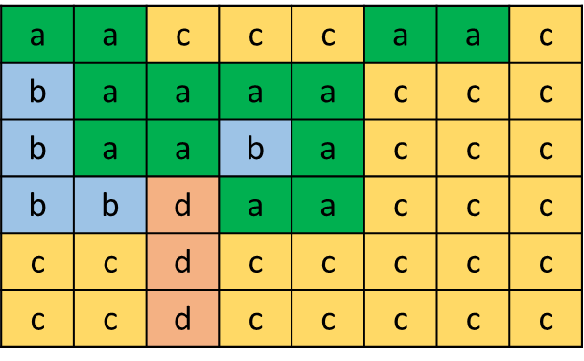 | Areas: 8  Letter 'a' -> 2  Letter 'b' -> 2  Letter 'c' -> 3  Letter 'd' -> 1
Number of rows: 3  aaa  aaa  aaa | 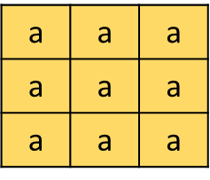 | Areas: 1  Letter 'a' -> 1
Number of rows: 5  asssaadas  adsdasdad  sdsdadsas  sdasdsdsa  ssssasddd | a s s s a a d a s  a d s d a s d a d  s d s d a d s a s  s d a s d s d s a  s s s s a s d d d | Areas: 21  Letter 'a' -> 6  Letter 's' -> 8  Letter 'd' -> 7
Hint: Initially mark all cells as unvisited. Start a recursive DFS traversal (or BFS) from each unvisited cell and mark all reached cells as visited. Each DFS traversal will find one of the connected areas.

Cycles in a Graph
Write a program to check whether an undirected graph is acyclic or holds any cycles.
Input | Picture | Output
C – G | 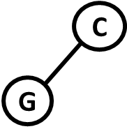 | Acyclic: Yes
A – F  F – D  D – A | 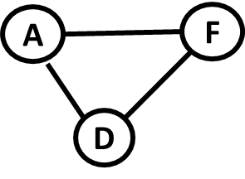 | Acyclic: No
E – Q  Q – P  P – B | 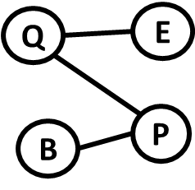 | Acyclic: Yes
K – J  J – N  N – L  N – M  M – I | 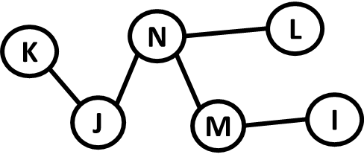 | Acyclic: Yes
K – X  X – Y  X – N  N – J  M – N  A – Z  B – P  I – F  A – Y  Y – L  M – I  F – P  Z – E  P – E | 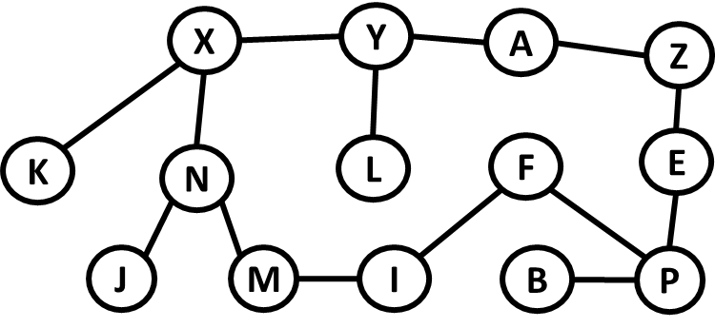 | Acyclic: No
Hint: Modify the Topological Sorting algorithm (source removal or DFS-based).

Salaries
You can test your solution to the problem in the Judge system here.
We have a hierarchy between the employees in a company. Employees can have one or several direct managers. People who manage nobody are called regular employees and their salaries are 1. People who manage at least one employee are called managers. Each manager takes a salary which is equal to the sum of the salaries of their directly managed employees. Managers cannot manage directly or indirectly (transitively) themselves. Some employees might have no manager (like the big boss). See a sample hierarchy in a company along with the salaries computed following the above described rule:
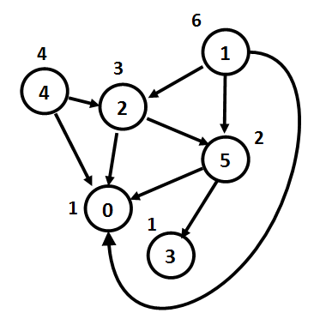
In the above example the employees 0 and 3 are regular employees and take salary 1. All others are managers and take the sum of the salaries of their directly managed employees. For example, manager 1 takes salary 3 + 2 + 1 = 6 (sum of the salaries of employees 2, 5 and 0). In the above example employees 4 and 1 have no manager.
If we have N employees, they will be indexed from 0 to N – 1. For each employee, you’ll be given a string with N symbols. The symbol at a given index i, either 'Y' or 'N', shows whether the current employee is a direct manager of employee i.
Hint: find the node with no parent and start a DFS traversal from it to calculate the salaries on the tree recursively.

Input
- The input data should be read from the console.
- On the first line you’ll be given an integer N.
- On the next N lines you’ll be given strings with N symbols (either 'Y' or 'N').
- The input data will always be valid and in the format described. There is no need to check it explicitly.

Output
- The output should be printed on the console. It should consist of one line.
- On the only output line print the sum of the salaries of all employees.

Constraints
- N will be an integer in the range [1 … 50].
- For each i-th line, the i-th symbol will be 'N'.
- If employee A is the manager of employee B, B will not be a manager of A.
- Allowed working time for your program: 0.1 seconds. Allowed memory: 16 MB.

Examples
Input | Output | Comments
1  N | 1 | Only 1 employee with salary 1.
4  NNYN  NNYN  NNNN  NYYN | 5 | We have 4 employees. 0, 1, and 3 are managers of 2. 3 is also a manager of 1. Therefore:  salary(2) = 1  salary(0) = salary(2) = 1  salary(1) = salary(2) = 1  salary(3) = salary(2) + salary(1) = 2
6  NNNNNN  YNYNNY  YNNNNY  NNNNNN  YNYNNN  YNNYNN | 17 | 

* Break Cycles
You are given undirected multi-graph. Remove a minimal number of edges to make the graph acyclic (to break all cycles). As a result, print the number of edges removed and the removed edges. If several edges can be removed to break a certain cycle, remove the smallest of them in alphabetical order (smallest start vertex in alphabetical order and smallest end vertex in alphabetical order).
Examples:
Input | Picture | Output | Picture After Removal
1 -> 2, 5, 4  2 -> 1, 3  3 -> 2, 5  4 -> 1  5 -> 1, 3  6 -> 7, 8  7 -> 6, 8  8 -> 6, 7 | 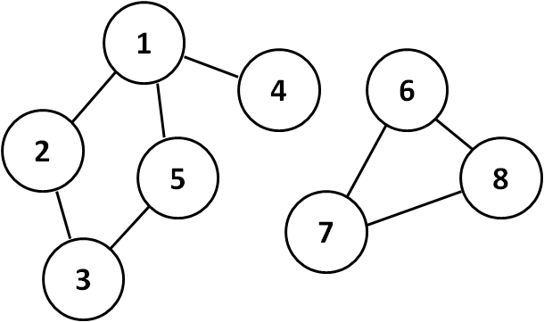 | Edges to remove: 2  1 – 2  6 - 7 | 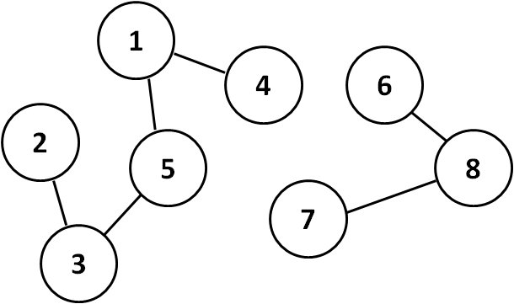
K -> X, J  J -> K, N  N -> J, X, L, M  X -> K, N, Y  M -> N, I  Y -> X, L  L -> N, I, Y  I -> M, L  A -> Z, Z, Z  Z -> A, A, A  F -> E, B, P  E -> F, P  P -> B, F, E  B -> F, P | 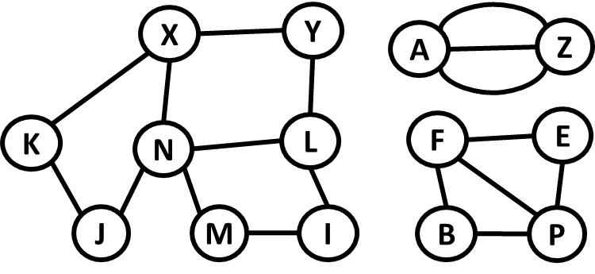 | Edgeds to remove: 7  A - Z  A - Z  B - F  E - F  I - L  J - K  L - N | 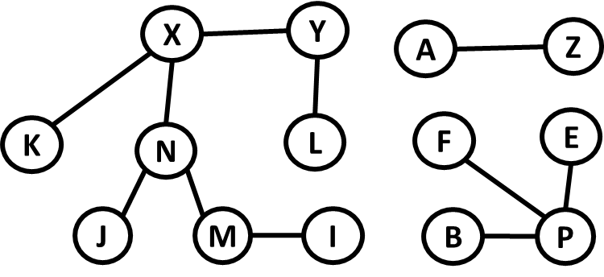
Hint: enumerate edges {s, e} in alphabetical order. For each edge {s, e} check whether it closes a cycle. If yes, remove it. To check whether an edge {s, e} closes a cycle, temporarily remove the edge {s, e} and then try to find a path from s to e using DFS or BFS.

